## Part A: Timeline

1. Check statistics of people returning vs new tourists, and average income of people visiting.
   1. Estimated Time: ½ day
2. check the 'about the island' details
   1. Estimated time: ½ day
3. using the details between the two supplied documents, create seperate personas for new tourists, repeat tourists with opportunties for events like exotic weddings and honeymoons, opportunities for business, and plans for expansion for the island.
   1. 1 day
4. Create wireframes for the different personas and pages
   1. ½ day
5. use social media forum board sites to do guerrilla usability testing, and recieve feedback
   1. 2 days
6. Use github to host interactive website for tanitian website, with properly cited documents.
   1. 2 days

I need to look at usability testing content to ensure that I have tasks available for people to test for task 2 as well.

## Part B Persona:

This section includes general information, a specific persona will be attached below as well.

General information:

For those taking vacations to the island, there are two major groups. Couples and families. Couples will have more income available to spend, compared to families, but having a decent number of families arrive on the island will still bring economic benefits to the island.

For couples, a majority of them are arrving by air travel, if they are vacationing, and prefer a private house of beach house, which leads me to believe adding some private beach houses, or a group of beach houses as a private resort a bit further away from the airport along with some advertising of said private resort will lead to more people tempted to visit. For those that are on their honeymoons, adding amenities that will help them plan their weddings at the island, will lead to a large increase in tourism on the island. There is a split on the couples who visit the island who want to see local attractions at the island, so with a boost to wedding venue items, hopefully that would assist with an increase of tourism there.

For families visiting the island, a majority of them wanted to see attractions on or around the island, and a majority of them came via cruise ships. Working with cruse ship companies to have families spend a couple days there, plus around the region would be a large economic boon to the economies of all the islands in the region. The issue being that families dont spend as much time on the island. If families are only spending 3-5 days on the island, and couples are spending 7-16 days on the island, the daily economic impact is larger for couples. There is a fallacy in only investing in couples only amenities though. Having family amenities would help bring couples back after they had families to the island as well.

Specific Persona:

* Name: Brett Stephens
* Age: 43
* Salary: 250,000 USD
* Island Transportation: Rental Car
* Method of Travel to Island: Plane
* Stay Duration: 7 days
* Party: Brett + Partner
* Staying: Private Condo



(Piacquadio, A, nd)

Summary: Brett and his significant other wants to take a break from their daily life. He's interested in immersing in the island life, and wants to know what the island has to offer.

NEEDS

* Relaxation: A break from the high-pressure environment of investment banking to unwind and de-stress.
* Comfort: High standards for accommodation, requiring a well-maintained and upscale private condo.
* Activity Variety: Access to a range of activities to make the most of his vacation time, including cultural experiences, dining, and outdoor adventures.
* Information: Detailed insights into local attractions, dining options, and unique experiences to fully explore and enjoy the island.
* Efficiency: Streamlined logistics for transportation and booking to avoid any additional stress during the vacation.

FRUSTRATIONS

* Poor Planning: Lack of clear, organized information about island activities and accommodations.
* Overcrowded Spots: Disappointment with crowded tourist attractions or overly commercialized areas that detract from the relaxation experience.
* Limited Connectivity: Issues with internet or phone service that disrupt work-life balance or hinder access to necessary information.
* Inadequate Service: Unmet expectations for quality of service or amenities in the condo or from local service providers.

FEELINGS

* Anticipation: Excitement about escaping daily routines and exploring a new environment.
* Restlessness: Potential anxiety about not achieving the level of relaxation or enjoyment he desires.
* Contentment: Satisfaction from engaging in well-planned activities and enjoying high-quality services.
* Curiosity: Interest in learning about and experiencing the local culture, cuisine, and natural beauty.

PERSONALITY

* Driven: Highly motivated and ambitious, with a strong focus on achieving success in his career.
* Detail-Oriented: Pays close attention to details and expects a high level of precision and quality.
* Adventurous: Open to trying new experiences and exploring different aspects of island life.
* Reserved: Prefers to enjoy downtime in a calm and private setting rather than in large, social gatherings.

## Part C: Wireframes

A page will generally look like this:

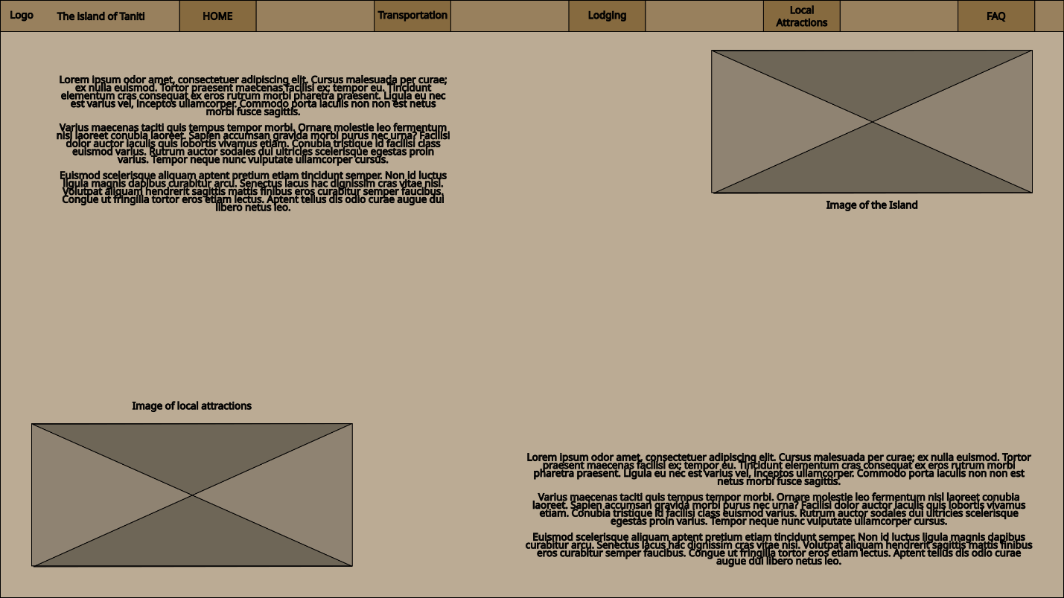

The FAQ will look similar to this:

The website flow will look similar to this:

## Section D: User feedback

Dusty:

* Qualitative feedback - Colors could be more engaging (background too neutral)
  + Actionable - Adjust the color scheme to ensure proper engagement for the page. The tan background is too bland.
* Qualitative feedback - Website layout is decent, content wise
  + Unactionable - nothing needs to be changed
* Qualitative feedback - The Q&A might be visually overwhelming.
  + Actionable - Reduce the Q&A items, and include a contact form for any more minor questions

Erica:

* Qualitative feedback - It took me a while to find the contact information
  + Actionable - Make the contact information more prominent and easier to locate, such as placing it in the header or footer.
* Qualitative feedback - The website doesn’t offer enough information about the services provided.
  + Actionable: Add more detailed descriptions and information about the services to give users a better understanding.
* Qualitative feedback - Put local attractions before transportation and lodging
  + Actionable - Adjusting Page order might increase the odds of people deciding they want to come to the island.

Josh:

* Qualitative feedback - The reference photos attached were blurry
  + Actionable - upload the higher resolution images, add caching and image sizing based on device
* Qualitative feedback - The color scheme blends together too much
  + Actionable - change color scheme
* Qualitative Feedback: The website doesn’t offer that much information about the services provided.
  + Actionable - ensure that information on each page has a decent amount of information for each of the pages

Part E is attached Via a github pages URL to submission.

## Part F, Usability testing:

Here are the questions I'd ask users testing the functionality and content of the island.

* What kind of currency is used on the island?
* What kind of accomodations for travellers are available on the island?
* Are there other islands close by? How would you travel to other islands close by.
* What kind of food is available?
* What cultural items can be seen on the island region?

## Part G, Sources:

awcadwel. (2021, February 15). [Homemade] Fresh Tagliatelle, Butter Poached Lobster, Morel-Lobster Cream Sauce [Reddit Post]. R/Food. www.reddit.com/r/food/comments/lkot87/homemade_fresh_tagliatelle_butter_poached_lobster/

Chensiyuan. (2006, May 14). File:Surf and turf (1).JPG - Wikipedia. https://commons.wikimedia.org/wiki/File:Surf_and_turf_(1).JPG

dancing Tahitian—Main. (2020, November 3). https://web.archive.org/web/20201103201239/http://dancingtahitan.weebly.com/

mushy--. (2020, November 3). Another Lake Superior shot from Marquette, MI 😌 [Reddit Post]. R/GreatLakesPics. www.reddit.com/r/GreatLakesPics/comments/jn0tj8/another_lake_superior_shot_from_marquette_mi/

Onionman775. (2024, September 1). Spent the last week camping on an island in Maine. Grilled local seafood every night. [Reddit Post]. R/Seafood. www.reddit.com/r/Seafood/comments/1f6evyv/spent_the_last_week_camping_on_an_island_in_maine/

OReilly, P. (1977). La danse à Tahiti. Nouvelles éditions latines.

Piacquadio, A. (n.d.). Man Holding Teacup Infront of Laptop on Top of Table Inside the Room. Pexels. Retrieved September 2, 2024, from https://www.pexels.com/photo/man-holding-teacup-infront-of-laptop-on-top-of-table-inside-the-room-925786/

Rivaud, V. (n.d.). White Boats on Body of Water. Pexels. Retrieved September 2, 2024, from https://www.pexels.com/photo/white-boats-on-body-of-water-2265876/

Skipperrutts. (2020, March 28). [Homemade] Spicy Miso Ramen with Duck [Reddit Post]. R/Food. www.reddit.com/r/food/comments/fqjug9/homemade_spicy_miso_ramen_with_duck/

Straight_Spring9815. (2024, August 27). I do hvac and a customer caught wind its my birthday coming up. [Reddit Post]. R/Seafood. www.reddit.com/r/Seafood/comments/1f2lcn4/i_do_hvac_and_a_customer_caught_wind_its_my/